**Practical – 3**

**Aim – Create a database and create the tables given below and execute the mentioned queries on this database.**

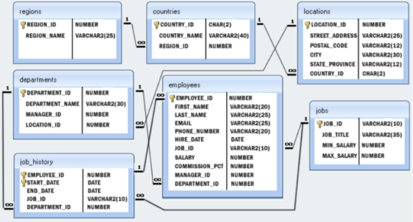**Schema –**

**Tables –**

* **Regions –**

Query - *CREATE TABLE regions(REGION_ID INT PRIMARY KEY, REGION_NAME VARCHAR(25));*

**Table schema**

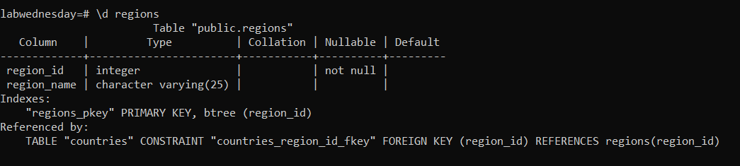

**Table Data**

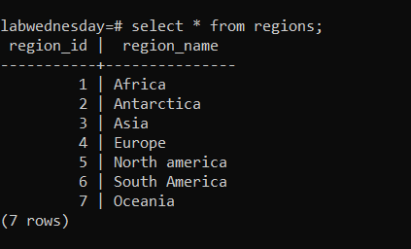

* **Countries -**

Query –*CREATE TABLE countries (COUNTRY_ID CHAR(2) primary key, COUNTRY_NAME VARCHAR(40), REGION_ID INT REFERENCES regions(REGION_ID));*

**Table schema**

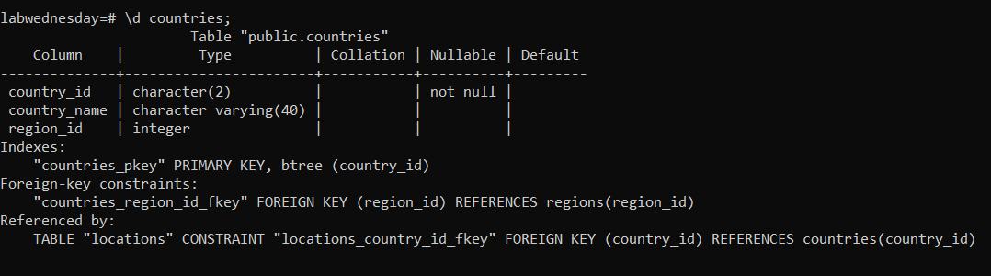

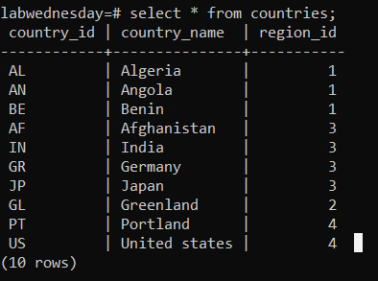**Table data**

* **Locations –**

Query - *CREATE TABLE locations (LOCATION_ID INT PRIMARY KEY, STREET_ADDRESS VARCHAR(25), POSTAL_CODE VARCHAR(12), CITY VARCHAR(30), STATE_PROVINCE VARCHAR(12), COUNTRY_ID CHAR(2) REFERENCES countries(COUNTRY_ID));*

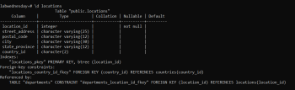**Table Schema**

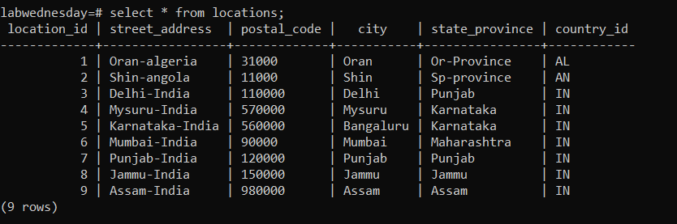 **Table Data**

* **Departments –**

Query - *CREATE TABLE departments (DEPARTMENT_ID INT, DEPARTMENT_NAME VARCHAR(30), MANAGER_ID INT, LOCATION_ID INT REFERENCES locations(location_id), primary key(department_id));*

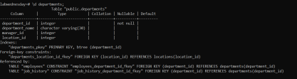 **Table schema**

**Table Data**

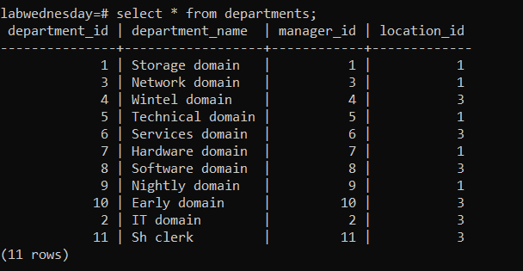

* **Employees –**

Query - *CREATE TABLE employees(employee_id int, first_name varchar(20), last_name varchar(25), email varchar(25), phone_number varchar(20), hire_date date, job_id varchar(10) references jobs(job_id), salary int, commission_pct int, manager_id int, department_id int references departments(department_id), primary key(employee_id));*

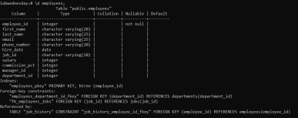**Table schema**

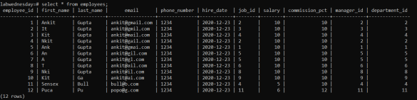 **Table Data**

* **Jobs –**

Query- *CREATE TABLE jobs (job_id varchar(10) primary key, job_title varchar(35), min_salary int, max_salary int);*

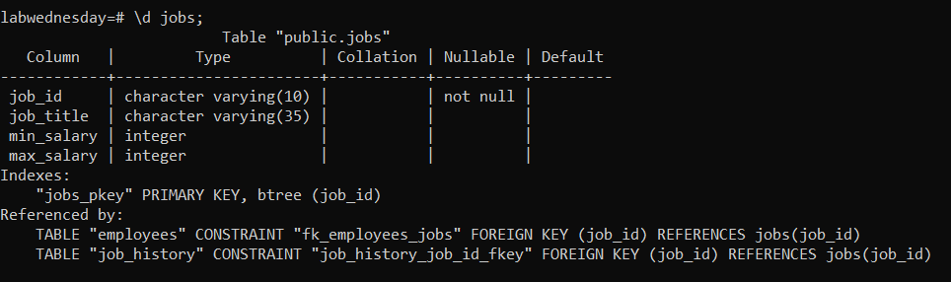 **Table schema**

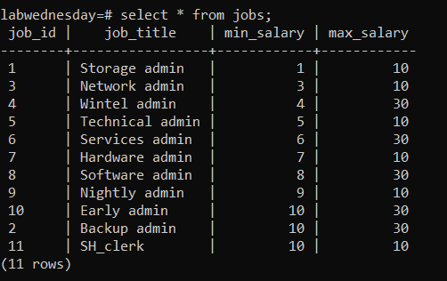 **Table Data**

* **Jobs history –**

Query - *CREATE TABLE job_history(employee_id int references employees(employee_id), start_date date, end_date date, job_id varchar(10) references jobs(job_id), department_id int references departments(department_id), primary key(employee_id, start_date));*

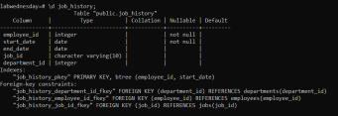 **Table schema**

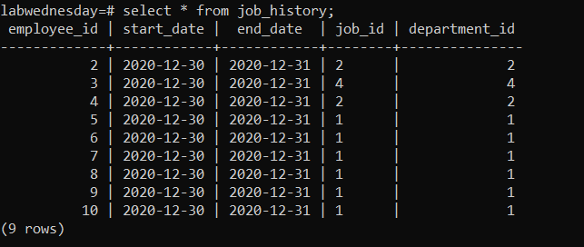 **Table Data**

**Queries –**

1. **Write a query to find the first_name, last_name and salaries of the employees who have a higher salary than the employee who’s last_name is Bull.**

Sol.

Query - *select first_name, last_name, salary from employees where salary > (select salary from employees where last_name='Bull');*

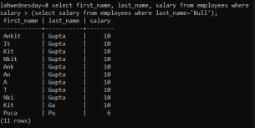**Output :**

1. **Write a SQL subquery to find the first_name and last_name of all employees who works in the IT department.**

Sol.

Query - *select first_name, last_name from employees where department_id in (select department_id from departments where department_name LIKE 'IT%');*

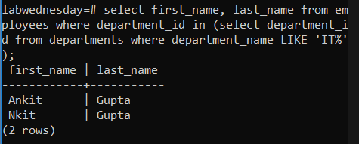**Output :**

1. **Write a SQL subquery to find the first_name and last_name of the employees under a manager who works for a department based in the United States.**

Sol.

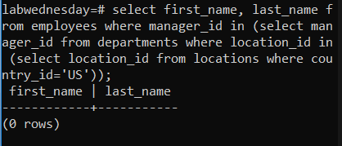Query - *select first_name, last_name from employees where manager_id in (select manager_id from departments where location_id in (select location_id from locations where country_id='US'));*

**Output :**

1. **Write a SQL subquery to find the first_name and last_name of the employees who are working as a manager.**

Sol.

Query- *select first_name, last_name from employees where employee_id in (select manager_id from departments);*

**Output :**

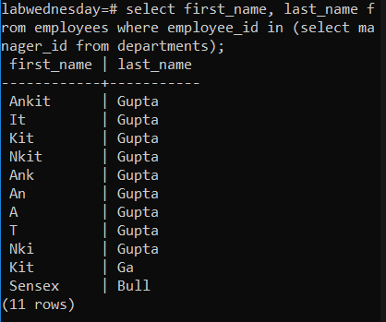

1. **Write a SQL subquery to find the first_name, last_name and salary, which is greater than the average salary of the employees.**

Sol.

Query- *select first_name, last_name, salary from employees where salary > (select avg(salary) from employees);*

**Output :**

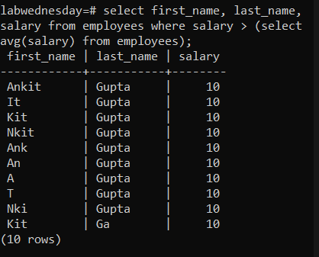

1. **Write a SQL subquery to find the first_name, last_name and salary, which is equal to the minimum salary for this post, he/she is working on.**

Sol.

Query - *select first_name, salary from employees e where salary = (select min_salary from jobs where job_id=e.job_id);*

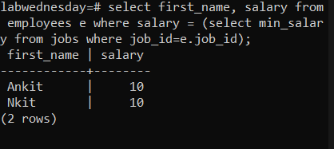**Output :**

1. **Write a SQL Subquery to find the first_name, last_name and salary of the employees who earn more than the average salary and works in any of the IT departments.**

Sol.

Query- *select first_name, last_name, salary from employees where salary > (select avg(salary) from employees) AND department_id = (select department_id from departments where department_name LIKE 'IT%');*

**Output :**

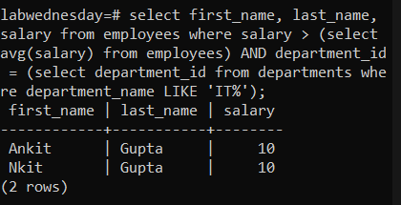

1. **Write a subquery to find the first_name, last_name, job_id and salary of the employees who draws a salary that is higher than the salary of all the Shipping Clerk (JOB_ID = 'SH_CLERK'). Sort the results on salary from the lowest to highest.**

Sol.

Query - *select first_name, last_name, job_id, salary from employees where salary > (select max(salary) from employees where job_id='11');*

**Output :**

